SIMATS ENGINEERING
SAVEETHA INSTITUTE OF MEDICAL AND TECHNICAL SCIENCES
CHENNAI – 602105
Department of Computer Science and Engineering

ASSESSMENT TOOL 1 – DATA INTERPRETATION

Course Code: | DSA05 | Course Title: | Query Processing for Data Science With Real Time Applications
CO Assessed: | CO1 | Assessment: | Tool 2 – Schema Analysis and Viva Voce
Weightage: |  | Total Marks: | 20 Marks
CO2 Statement: Use Python basics and SQL libraries to connect to databases SQLite, MySQL, PostgreSQL and perform CRUD operations like Create, Read, Update, Delete. (BTL6)
Student Name: | G Rajasekhar Reddy | Reg. No.: | 192424216
Section / Batch: | BTech-AI&DS | Date of Submission: | 20-07-2026
Faculty In-charge: | Dr. B. Shyamala Gowri | Project Mode: | Individual Submission

Code of Conduct
I G .Rajasekhar Reddy(192424216) (Name / Reg No) certify that this submission is my original work and that I have adhered to all guidelines specified for this assessment. I understand that any violation of academic integrity rules will result in disciplinary action.
Signature: G. Rajasekhar Reddy

Requirement Analysis (4 Marks) | ER Diagram Design (4 Marks) | Table Design & Normalization (4 Marks) | Database Connectivity using Python (4 Marks) | CRUD Operations (4 Marks) | Total (20 Marks)

19. Weather Data Analysis
Files:
• Weather.csv
• Stations.csv
• Weather.json
• Weather.xml
Read weather datasets from CSV, JSON, and XML. Merge weather and station data,
calculate monthly average temperature, identify extreme weather conditions,
summarize seasonal rainfall, and export the cleaned dataset.
Program:
import pandas as pd

weather_csv = pd.read_csv("Weather.csv")
stations = pd.read_csv("Stations.csv")
weather_json = pd.read_json("Weather.json")
weather_xml = pd.read_xml("Weather.xml")

weather = pd.concat([weather_csv, weather_json, weather_xml], ignore_index=True)

merged = pd.merge(weather, stations, on="Station_ID")

merged["Date"] = pd.to_datetime(merged["Date"])

merged["Month"] = merged["Date"].dt.month

monthly_avg = merged.groupby("Month")["Temperature"].mean()

extreme_weather = merged[(merged["Temperature"] > 40) | (merged["Temperature"] < 5)]

def season(month):
if month in [12, 1, 2]:
return "Winter"
elif month in [3, 4, 5]:
return "Summer"
elif month in [6, 7, 8, 9]:
return "Monsoon"
else:
return "Post-Monsoon"

merged["Season"] = merged["Month"].apply(season)

seasonal_rainfall = merged.groupby("Season")["Rainfall"].sum()

merged.to_csv("Cleaned_Weather.csv", index=False)

print("Monthly Average Temperature")
print(monthly_avg)

print("\nExtreme Weather")
print(extreme_weather)

print("\nSeasonal Rainfall")
print(seasonal_rainfall)

print("\nCleaned dataset exported successfully.")

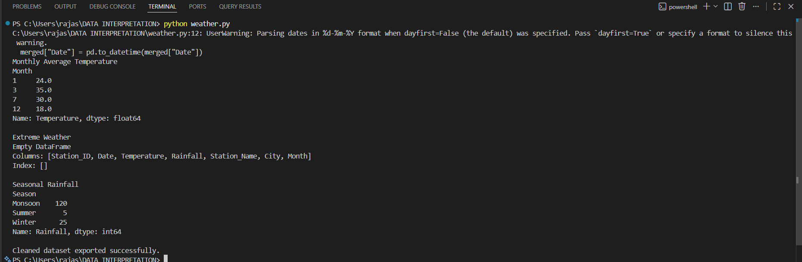
Output:
20. COVID-19 Vaccination Analysis
Files:
• Vaccination.csv
• Districts.csv
• Vaccination.json
• Vaccination.xml
Read vaccination datasets from multiple formats. Merge vaccination and district
records, calculate vaccination percentage, identify low-coverage districts, summarize
vaccine usage, and export the cleaned dataset.

Program:
import pandas as pd

vaccination_csv = pd.read_csv("Vaccination.csv")
districts = pd.read_csv("Districts.csv")
vaccination_json = pd.read_json("Vaccination.json")
vaccination_xml = pd.read_xml("Vaccination.xml")

vaccination = pd.concat([vaccination_csv, vaccination_json, vaccination_xml], ignore_index=True)

merged = pd.merge(vaccination, districts, on="District_ID")

merged["Vaccination_Percentage"] = (merged["Vaccinated"] / merged["Population"]) * 100

low_coverage = merged[merged["Vaccination_Percentage"] < 70]

vaccine_usage = merged.groupby("Vaccine")["Vaccinated"].sum()

merged.to_csv("Cleaned_Vaccination.csv", index=False)

print("Vaccination Percentage")
print(merged[["District_Name", "Vaccination_Percentage"]])

print("\nLow Coverage Districts")
print(low_coverage[["District_Name", "Vaccination_Percentage"]])

print("\nVaccine Usage")
print(vaccine_usage)

print("\nCleaned dataset exported successfully.")

Output:
